**TIRE PLACARD EXAMPLE**

The information on here will need to pull from fields in GSS and generate a label like the one shown below that is attached to the trailer.

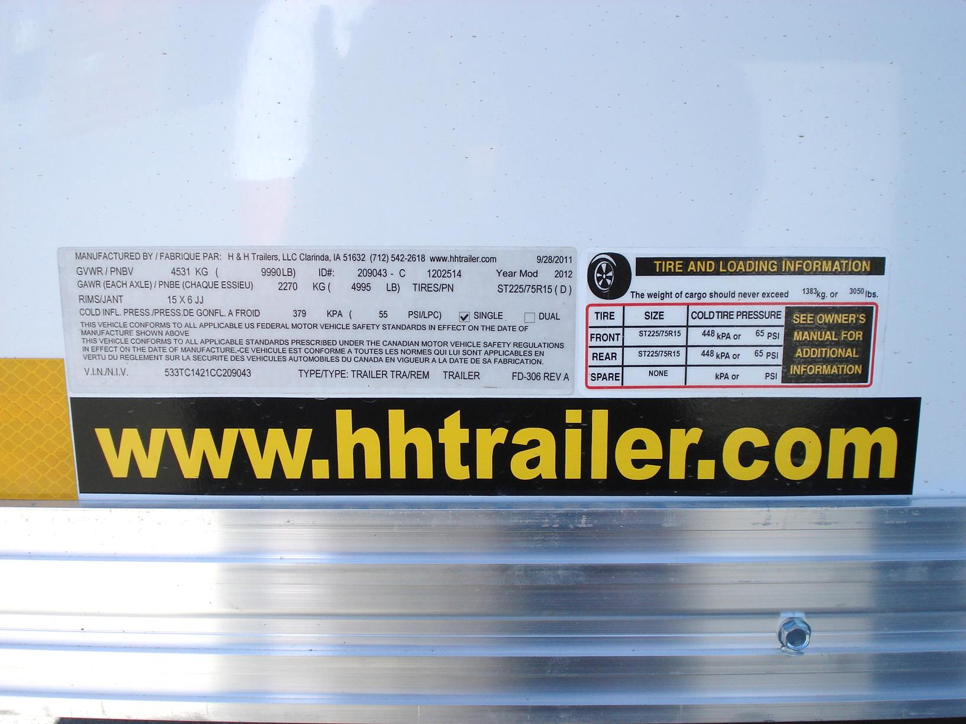

**B**

**A**

The current app they use to print tire placards has them type in all the pieces of information.

**A – cargo weight**

This weight is calculated by subtracting the actual weight of the trailer from the suspension weight rating. This is the weight that the trailer can legally haul.

For example if the suspension is a 7K and the weight of the trailer is 1540 lbs,

then 7000 – 1540 = 5560

and this 5560 is entered in the lbs field (and then they have to calculate the kg)

The 7000 can be added to a field in the inventory part numbers for the suspension choice on the trailer order. Let me know if we need to figure out a field we can use. It needs to be defaulted to the suspension rating but available to type over. For example our 10K rated trailers are actually 9990. We sometimes down rate it to 9000 so we need to be able to change it then have it used in the calculation for cargo weight.

The trailer weight, 1540 – the trailer will have to physically be weighed then the weight typed in at a prompt. I’m thinking this will have to be before WIP to FG?? I’m not sure what triggers the final forms to be printed (like BOL, NAFTA, MSO etc).

**B**

Front is an axle, Rear is a second axle (tandem), Spare if a spare is included

If the trailer is only a single axle, only Front row is filled in and None has to be printed in the Rear row. If there is a Spare, the Front tire can be copied into that row, otherwise it has to say None. (new regulations from the government)

If it is a triple axle, the 3rd axle is just ignored since it will be the same as the 1st two tire sets.

If there is a spare included, it will always be the same as the Front, so it can be copied to the Spare row.

The tire Size can be pulled from the Inventory Part record in the first part of the description field and the tires will be ones that are chosen on the order. I’m not sure of how or if you can pull that?

The Cold Tire Pressure is something they type in but is based on the chart that I’ve attached. It looks at the size 205/225/etc.

Much of this can be used on the VIN tag (see attached).